Lecture Plan: Teaching Spring Boot REST API Development
This lecture is designed for students who are new to Spring Boot and REST API development. The goal is to make them understand what Spring Boot is, how it works, and how to create their first REST API. The session will include both theory and hands-on exercises.

📌 1: Introduction to Spring Boot
🔹 What is Spring Boot?
- Spring Boot is a framework that simplifies Java-based web application development.
- It is built on top of the Spring Framework and provides default configurations.
- It helps developers create stand-alone, production-ready applications with minimal setup.
- No need for XML configuration! Spring Boot uses annotations instead.
🔹 Why Do We Use Spring Boot for REST APIs?
- Simplifies API development with built-in tools.
- Comes with an embedded server (Tomcat/Jetty).
- Has built-in support for JSON responses.
- Automatic dependency management (using Maven or Gradle).
- Microservices-friendly (can be used with Spring Cloud).
💡 Real-World Example
Imagine building a weather app that fetches live weather data from a server. The backend (Spring Boot) provides REST APIs like:
GET /api/weather?city=Bangalore

Response:
{
"city": "Bangalore",
"temperature": "30°C",
"humidity": "65%"
}

REST API, or Representational State Transfer API, is a type of application programming interface (API) that allows different applications to communicate with each other. REST APIs are often used for mobile app development and the Internet of Things (IoT).
How does REST API work?
- REST APIs use HTTP requests to communicate with web services.
- They follow a stateless protocol, where each request is treated independently.
- Clients can access and manipulate resources using standard HTTP methods like GET, POST, PUT, and DELETE.
- REST APIs are designed to support high-performing and reliable communication at scale.
Why is REST API popular?
- REST APIs are considered easier to use than other protocols like SOAP (Simple Object Access Protocol).
- They are faster and more lightweight, with increased scalablity.
- They provide a flexible, lightweight way to integrate applications.
Examples of REST APIs in use
- Twitter's REST API provides developers with access to tweet data.
- Instagram's API provides endpoints for interaction with photos, users, and analytics.

📌 2: Understanding the Project Structure
When we create a Spring Boot project, it has a default folder structure:
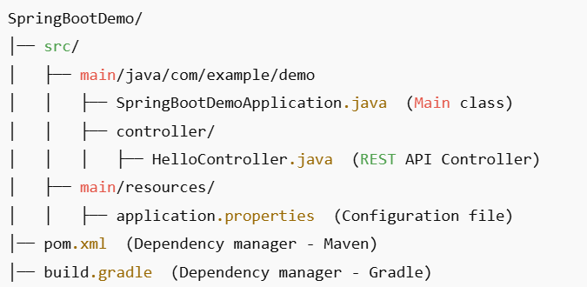

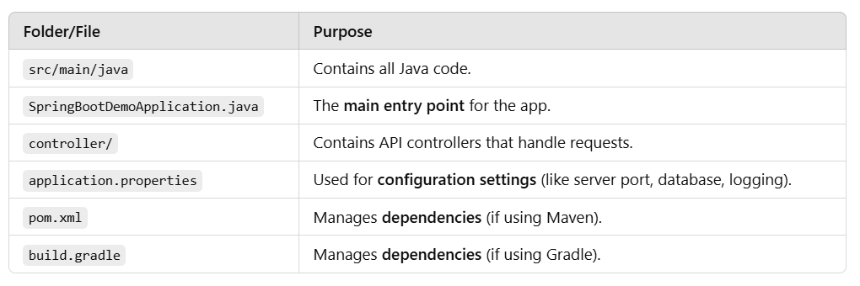

📌 3: Understanding SpringBootDemoApplication.java
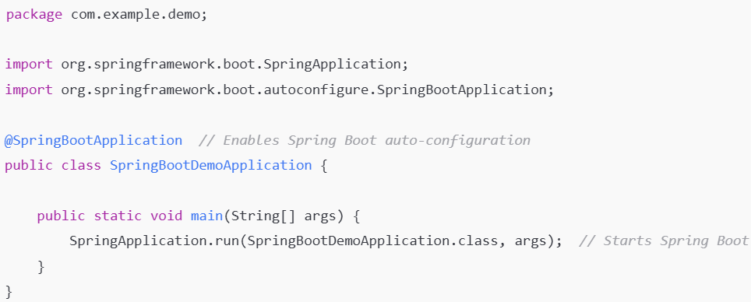

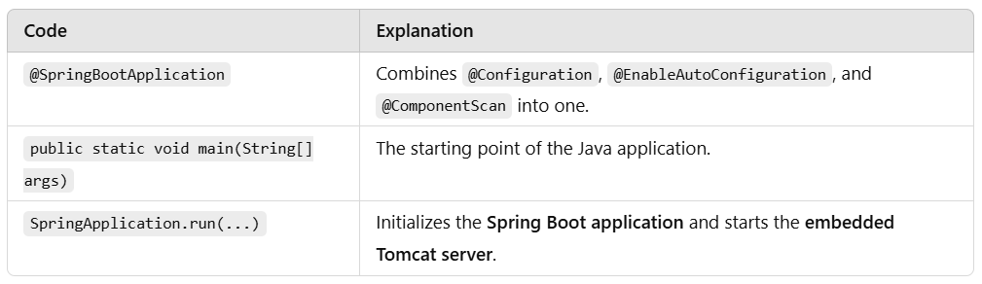

📌 4: Understanding HelloController.java
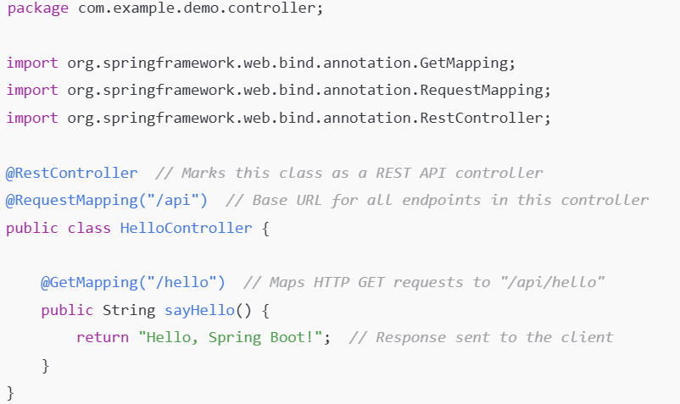
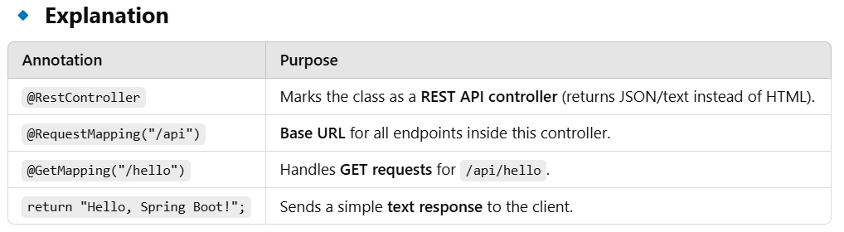

🔹 Hands-On Exercise
- Run the program and test the API in a browser:
http://localhost:8080/api/hello
- Expected Output:
Hello, Spring Boot!

📌 5: Hands-On - Running the Project in Eclipse
🔹 Step 1: Install Required Software
- Install Java JDK 17 or later
- Download Eclipse IDE
- Install Spring Boot Plugin (STS - Spring Tool Suite)
🔹 Step 2: Create a New Spring Boot Project
- Go to File → New → Spring Starter Project.
- Enter:
  - Project Name: SpringBootDemo
  - Group: com.example
  - Artifact: demo
- Select Spring Web, then click Finish.
🔹 Step 3: Add Code
- Inside src/main/java/com/example/demo/controller/, create a new Java class HelloController.java and add the code.
🔹 Step 4: Run the Application
- Right-click SpringBootDemoApplication.java → Run As → Spring Boot App.

📌 6: Assign Practical Tasks
Task 1: Change the Endpoint
- Modify the controller to use /api/greet instead of /api/hello.
- Expected URL: http://localhost:8080/api/greet
- Expected Output: "Hello, Spring Boot!"

Task 2: Return a JSON Response
- Modify HelloController.java to return a JSON response instead of plain text.
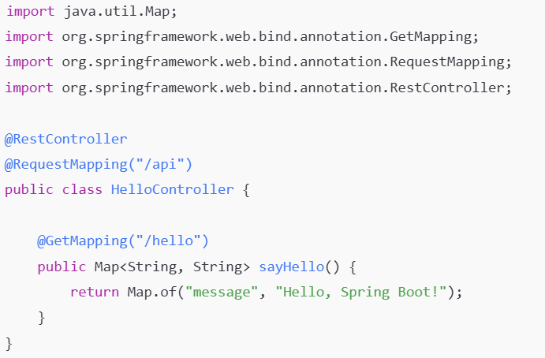

Expected Output (JSON):
{
"message": "Hello, Spring Boot!"
}

Task 3: Introduce Query Parameters
- Modify the API to accept a user’s name and return a personalized message.
@GetMapping("/hello")
public Map<String, String> sayHello(@RequestParam(defaultValue = "Guest") String name) {
return Map.of("message", "Hello, " + name + "!");
}
- Test with URL:
http://localhost:8080/api/hello?name=DSU
- Expected Output:
{
"message": "Hello, DSU!"
}
🎯 Conclusion
✅ Students will now understand:
- What Spring Boot is and why we use it.
- How to create a REST API.
- How to run the project and test endpoints.
- How to modify APIs to return JSON responses.
- How to handle query parameters.

